COVID-19-Related Resources
This list includes educational resources for youth & parents; resources and information related to food security, supplies, financial assistance, and general support; resources and information related to housing, utilities, and technology; physical and mental health resources; resources specific to certain populations; resources organized by NYC neighborhood/borough; scientific and informational resources; and recursos en español et ressources en français.
It will be adapted as new information and resources become available.

Educational Resources for Youth & Parents
- Information on Remote Learning in Public Schools & FAQs: Basic information on remote learning with DOE and links to further resources. (Information translated into French, Spanish, Haitian Creole, Mandarin, Bengali, Russian, Urdu, Arabic, & Korean)
  - Creating your student account, which will allow you to access Google classroom and download Microsoft Office
  - Guide: Connecting to Google Classroom in English, Spanish, Creole
  - Step-by-step guide to using/information for connecting to Google Classroom and Microsoft Teams (English only)
    - FOR HELP: send a text to 718-673-2430 or call DOE Service Desk (718)-935-5100
  - Request remote learning devices - after filling it out, DOE will be in contact with you directly about where and when to pick up your internet-enabled device
  - If you do not have Wi-Fi to access remote learning:
    - Comcast - offering Essentials internet service designed for low-income families free for 60 days for new qualifying customers. Visit https://www.internetessentials.com/ for more information. Call 1-855-8-INTERNET for set up.
    - Charter cable (and possibly other providers) will offer free Spectrum broadband and Wi-Fi access for 60 days to households with K-12 and/or college students who do not already have a subscription, and installation fees will be waived for new student households: call 1-844-488-8395
    - AT&T is offering 60 days of free public service.
    - Spectrum is offering free broadband to households with students.
- FREE grab-and-go meals available for pick up at all schools 7:30am-1:30pm
  - You may go to any school, not necessarily the school you attend - find the closest location serving meals here.
  - No registration, ID, or documentation required.
  - All three meals a day may be picked up at the same time.
  - No dining space is available, so meals must be eaten off premises.
  - Parents and guardians may pick up meals for their children‎.
- Regional Education Centers are open across all 5 boroughs and staffed by school personnel and members of community-based organizations to provide 3 hot meals per day, remote learning access, and other activities for children whose parents are working as health care workers, transit workers, FDNY/NYPD, etc. Centers will be open starting March 23 from 7:30am - 6:00pm Monday-Friday. To comply with social distancing protocol while supporting students, each room will have a maximum of 12 students with at least 1 adult supervisor, and placement will be based on the student's home address.
  - Enrollment form can be found here
  - Information translated into French, Spanish, Haitian Creole, Mandarin, Bengali, Russian, Urdu, Arabic, & Korean can be found here
- Enrolling in school: Family Welcome Center (FWC) staff are available remotely to assist with enrollment and placement of new admissions, questions around admissions, information about offers, and waitlists. To receive direct support e-mail your questions to (and/or call 311):
  - Bronx: bronxfwc@schools.nyc.gov
  - Brooklyn: brooklynfwc@schools.nyc.gov
  - Manhattan: manhattanfwc@schools.nyc.gov
  - Queens: queensfwc@schools.nyc.gov
  - Staten Island: statenislandfwc@schools.nyc.gov
- NYC Department of Education - Remote Activities for students:
  - Resources & activities for early childhood (available in English, French, Spanish, Haitian Creole, Mandarin, Bengali, Russian, Urdu, Arabic, & Korean)
  - Resources & activities for grades K-5 and for middle school, by grade level & subject (English only)
  - Resources & activities for high school, organized by subject and level, including Mathematics, Science, English Language Arts, Social Studies, and College & Career Planning (English only)
  - Resources & activities regarding health education for all students and their families, organized by age group (English only)
  - Free physical education activities: links to yoga classes, meditation/mindfulness, music for dancing, games, sports videos, and other ideas to encourage physical movement at home
  - Resources for students with special needs: social stories, visual aids, at home tips for speech, occupational therapy and physical therapy
- Reading resources
  - Time for Kids magazine offers news on topics that are interesting and encourage children to think about the world around them, for levels K-1, 2 3-4, 5-6 (English only)
  - Smithsonian Tween Tribune publishes daily news articles for kids levels K-12 (English & Spanish)
  - I Can Read offers books for emerging readers at all levels (English)
  - Story Online features famous actors reading kids books (mostly reading levels K-4) (English)
  - Audible is offering free streamable audio books for kids while schools are closed
  - United for Literacy has a free library of digital books (most for ages 3-8) (English & Spanish written; narration in more than 40 languages including ASL)
  - Downloadable reading bingo cards from Bookopolis
  - Get EPIC is a subscription-based e-book library, offering books for ages 3-12 as well as non-fiction and young adult fiction, free when invited by a teacher (English & Spanish)
  - NovelNY online library (access requires NYS non-driver-ID or driver’s license)
  - NYC Reads 365 offers reading lists by grade level and other activities
  - Common Lit provides texts, questions, and a parent guide for how to support their students (levels 3rd-12th grade) (English, Spanish)
- Other educational activities & resources
  - Free tutoring from NYPL: libraries offering free one-on-one tutoring for all students, every day 2pm-11pm, in English and Spanish, for early elementary through high school students
    - NYPL also links to many amazing resources to support kids as they learn, some accessible only through an NYPL account. Click the link about for more details, broken down by age level.
  - Crowd-sourced lists of free enrichment activities
    - http://www.amazingeducationalresources.com/
    - 275+ enrichment activities for kids
    - Anti-oppressive, anti-racist homeschooling resources
  - My Storybook allows kids to create, illustrate, and print, their own books
  - DK Find Out! lets kids find, explore, and learn about anything imaginable through a visual search engine, videos, and animations and more.
  - KidLit TV has videos, podcasts, radio, and activities promoting children’s literature
  - Online access to New York Public Library (e-books, music, newspapers and journals, language lesson plans, and more!) (site also available in Spanish)
  - Wonderopolis offers a “wonder of the day” to explore each day, with related online and offline activities
  - FOR PARENTS: Literacy Partners offers English & literacy courses
- Information about the coronavirus epidemic for kids (pre-K through high school) (English, Spanish, Chinese)

Food Security, Supplies, Financial Assistance, and General Support
- NYC public school students may pick up free grab-and-go breakfast and lunch from 7:30am-1:30pm outside the main entrance to every school building. Students may go to their regular school or the one closest to them.
- Invisible Hands: free delivery for at-risk communities, by volunteers in your neighborhood (site in English, but they have bilingual staff/volunteers to help with other languages!)
- Food Bank NYC - Find the help that you need
- Soup Kitchen and Food Pantries - offering hot meals or groceries - search by borough
- Abolition Action Grocery Fund - Donate via Paypal, Info via Tweet, new requests: request form
- WIC members can have baby formula delivered FREE to all New York City boroughs. Dial 718-405-9111
- Free Veggies for Restaurant Workers - Local Roots CSA is giving away free vegetables to restaurant workers that are without work and money right now: info@localroots.nyc
- Apply for unemployment benefits online or call 1-888-209-8124
- Requesting financial assistance from Mutual Aid (for anyone!) - English only for right now, but trying to get other languages
- C19 Help Squad: form to complete to obtain supplies and / or financial assistance, etc. (English site, but they have bilingual staff / volunteers to help with other languages)
- Coronavirus Financial Impact Loan to address lost wages due to being unable to go to work, child care costs due to school closures, small business losses, canceled study abroad programs, related medical costs
- Emergency funds for undocumented youth and families
- COVID Financial Solidarity request form for financial assistance from the community
- Resources for restaurant workers & delivery employees - organized nationally and by state
- National Domestic Workers Alliance Coronavirus Care Fund - Help fund for domestic workers
- Nueva Yorkinos has great resources and information in English, Spanish, and Portuguese
- Make the Road NY offices are closed but COVID hotline and other resources available
  - Bushwick, Brooklyn – (718) 418-7690
  - Jackson Heights, Queens – (718) 565-8500
  - Port Richmond, Staten Island – (718) 727-1222
  - Brentwood, Long Island – (631) 231-2220
  - White Plains, Westchester – (914) 948-8466
- See Resources by group and Resources by neighborhood for more specific resources

Housing, Utilities & Technology
- Eviction proceedings and pending orders will be suspended statewide until further notice. Housing court functions such as landlord lockouts, repair orders, and serious code violations will continue.
  - Tenants Rights Hotline - 212-979-0611 (ingles y espanol) or more info
  - Anyone with knowledge of City marshals attempting to execute on warrants of eviction can report this activity by calling DOI’s Bureau of City Marshals at (212) 825-5953.
  - Support for eviction prevention: Bronx Works, Catholic Charities - helps regardless of denomination, Coalition for the Homeless
- New York utilities have volunteered to suspend utility shut-offs for power, heat and water for all customers.
- Free WiFi at home:
  - Comcast - offering Essentials internet service designed for low-income families free for 60 days for new qualifying customers. Visit https://www.internetessentials.com/ for more information. Call 1-855-8-INTERNET for set up.
  - Spectrum - households with K-12 students can get free Spectrum Wifi for 60 days (including free installation for new customers). Call 1-844-488-8395 for set up.
- Free public WiFi:
  - Comcast - Xfinity WiFi hotspots will be available to anyone who needs them for free – including non-Xfinity Internet subscribers. For a map of Xfinity WiFi hotspots, visit www.xfinity.com/wifi.
  - AT&T - AT&T is also providing free access to its public WiFi hot spots. Look for "att-wifi" or "attwifi" in the list of available wireless networks from your smartphone or laptop.
- Wifi via smartphone:
  - Metro PCS, T-Mobile, Sprint, AT&T and Comcast are all lifting their unlimited data caps for cell phone subscribers for at least 60 days. Contact your cellphone provider for more information.
  - MetroPCS will allow you to add a free 10GB of mobile hotspot per month by adding an add on service available in the MyMetro app, MyAccount or by calling Care at 611.
  - T-Mobile and Metro by T-Mobile are providing customers an additional 20GB of mobile hotspot/tethering service for the next 60 days coming soon.

Health and Mental Health Resources
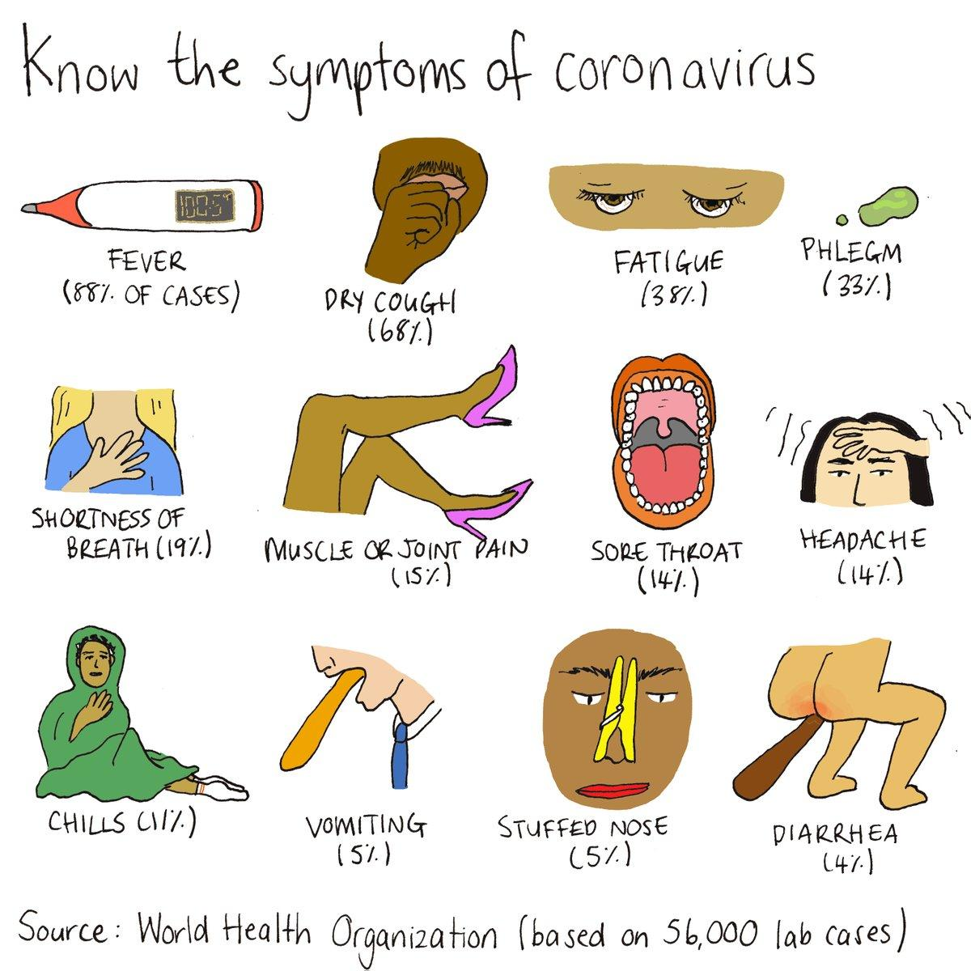
- NYC Department of Health page devoted to Coronavirus
- Text COVID to 692-692 for NOTIFY NYC Emergency Updates
- New York State Coronavirus Hotline - 1 (888) 364-3065
- News: live updates from New York Times
- Call 311 with any medical questions
- Wash your hands with soap for at least 20 seconds, wipe down surfaces frequently, and try to maintain 6ft (2 meters) between yourself and others when possible
- One Medical’s ‘What You Should Know About Coronavirus’ gives information about symptoms, testing, and protecting yourself
- CDC Fact Sheets in English, Spanish, Chinese, Vietnamese, Korean + What to do if you’re sick in English, Spanish, Chinese, Vietnamese, Russian, Dari, Farsi, Arabic, Swahili, Ukrainian
- Coronavirus Anxiety toolkit
- At-home list of mental health resources
- Mental Health NYC WELL Hotline/Chat available in more than 200 languages, 24/7/365
  - English: 1-888-NYC-WELL (1-888-692-9355), Press 2
  - Call 711 (Relay Service for Deaf/Hard of Hearing)
  - Español: 1-888-692-9355, Press 3
  - 中文: 1-888-692-9355, Press 4
- Mental Health Chat For Undocumented People- Instagram Live Chat
- Trevor Project mental health support for LGBTQ+ youth (ages 18-24)
  - 24/7 hotline ‘TrevorLifeline” - call 1-866-488-7386.
  - TrevorChat: Click on TrevorChat on the website and fill out the online form to be connected with a counselor. Confidential online instant messaging with a Trevor counselor is available 24/7.
  - TrevorText: Text “Start” to 678678 to connect with a trained counselor. Confidential text messaging with a Trevor counselor is available 24/7/365.
  - TrevorSpace: Join an affirming international community for LGBTQ young people ages 13-24. It is a safe and supportive environment for youth to connect with others and discuss various topics.
  - Support center resources
- Trans Lifeline - mental health support & other community resources: call 877-565-8860 to reach their peer support and crisis hotline

Resources specific to certain populations
- Information for immigrants regarding coronavirus
  - USCIS announced that testing, prevention, or treatment for COVID-19, also called Coronavirus, would NOT be used against immigrants in a public charge test. This means that immigrant families should seek the care they need during this difficult time
  - RIF Asylum Support resources for asylees and asylum seekers (English, Spanish, Russian)
- Resources in multiple languages (including Arabic, Chinese, and others), compiled by Asian-American, Native Hawaiian, and Pacific Islander groups
- List of resources for undocumented workers (also in Spanish)
  - NYSYLC has created a fund for undocumented youth and families in the wake of coronavirus crisis. Email info@nysylc.org for more information.
  - RAISE NYC Undocu Worker’s fund will support undocumented workers in the service industry. The fund will be distributed to undocumented workers at restaurants in Manhattan & Brooklyn. Email undocuworkersfund@gmail.com for more information.
  - Betancourt Macias Family Scholarship Foundation for undocumented families
- ROC United - resources for restaurant workers & delivery employees - organized nationally and by state
- Restaurant Workers Community Foundation information and resources
- Facebook group for parents
- RDJ Refugee Shelter provides temporary housing to asylum seekers and refugees
  - Address: St. Mary’s Episcopal Church -- 521 W.126 St. NY, NY between Old Broadway and Amsterdam -- Email: admin@rdjrefugeeshelter.org
- LGBTQ+ Resources for asylum seekers and other LGBTQ+ individuals
  - National Center for Lesbian Rights provides legal services to LGBTQ+ individuals across the country: call hotline at 1-800-528-6257 or 415-392-6257 or email Info@NCLRights.org
  - Queer Support Group with some possibility of financial assistance, supply delivery etc.
  - Trans Lifeline - mental health support & other community resources
    - Call 877-565-8860 to reach their peer support and crisis hotline
  - Trevor Project mental health support for LGBTQ+ youth (ages 18-24)
  - Heartland Alliance National Immigrant Justice Center LGBTQ Justice Initiative offers legal services - email lgbtimmigrants@heartlandalliance.org
  - Ali Forney Center for Homeless Youth (ages 16-24) is located at 321 W. 125th Street in Manhattan; open for new Intakes Monday-Friday from 8am-8pm and Saturday and Sunday from 10am-6pm; can be reached by phone at 212-206-0574
  - The Center: phone lines open at 212.620.7310 from 9 am to 10 pm, Monday through Saturday, and 9 am to 9 pm on Sundays.
    - COVID-19-specific referral guides for existing services and options spanning housing, food, recovery, family support, HIV testing and more to be shared on their website
- Black Folks COVID-19 Fund for funds and supplies from BYP 100 - donate viaPayPal, request form
- Black Trans Solidarity Fund for groceries from TheOkraProject - donate via Paypal, request form
- Co-quarantined with an abuser? Worried about having to self-isolate from coronavirus in a dangerous home situation? Please reach out — contact @ndvh | National Domestic Violence Hotline: CALL 1−800−799−7233 or TTY 1−800−787−3224 or CHAT at http://thehotline.org

Resources by NYC Neighborhood/Borough
- Black Trans Solidarity Fund for groceries from TheOkraProject - donate via Paypal, request form
- NYC Shut it Down Food Delivery - Providing free home cooked meals and groceries to black & brown folks in BK, BX, Queens, Harlem. Share with your neighbors, family, friends. Venmo: @nycshutitdown, instagram: @nyc_shutitdown, email: nycSIDfooddelivery@gmail.com
- Invisible Hands: free delivery for at-risk communities, by volunteers in your neighborhood (site in English, but they have bilingual staff/volunteers to help with other languages!)
- Food Bank NYC - Find the help that you need
- Soup Kitchen and Food Pantries - offering hot meals or groceries - search by borough
- Abolition Action Grocery Fund - Donate via Paypal, Info via Tweet, new requests: request form
- WIC members can have baby formula delivered FREE to all New York City boroughs. Dial 718-405-9111
- Free Veggies for Restaurant Workers - Local Roots CSA is giving away free vegetables to restaurant workers that are without work and money right now: info@localroots.nyc
- Make the Road NY offices are closed but COVID hotline and other resources available
  - Bushwick, Brooklyn – (718) 418-7690
  - Jackson Heights, Queens – (718) 565-8500
  - Port Richmond, Staten Island – (718) 727-1222
  - Brentwood, Long Island – (631) 231-2220
  - White Plains, Westchester – (914) 948-8466

Brooklyn
  - All Brooklyn Neighbor help: fill out the form to request or give aid
  - NYC Shut it Down Food Delivery - Providing free home cooked meals and groceries to black & brown folks in BK, BX, Queens, Harlem. Share with your neighbors, family, friends. Venmo: @nycshutitdown, instagram: @nyc_shutitdown, email: nycSIDfooddelivery@gmail.com
  - Bed Stuy: Open Door Family Life Center located at 999 Greene Ave. Bring bags or a cart. Food pantry distribution: Saturday 8:30 am- 10:30 am. Soup kitchen serving hot meals: 9:00am - 10:30am
  - Bed Stuy Strong - http://bit.ly/bedstuystrong (Slack) BedStuyStrong2020@gmail.com
  - Bed Stuy Food Not Bombs hands out groceries on Saturday at 3pm at corner of Marcy & Lafayette
  - BedStuy/Bushwick: Club A serves hot food, clothes, toiletries, & harm reduction supplies every Saturday (~2-5pm) at 354 Stockton St. (Myrtle & Broadway station) - instagram
  - Boerum Hill/Downtown BK Neighborhood services and support - Survey sign up
  - Brooklyn Mutual Aid Network (FAM) - Google Document, Tweet
  - Bushwick Mutual Aid - Coronavirus - Facebook Group
  - Carroll Gardens Mutual Aid - Coronavirus - Facebook Group
  - Central Brooklyn Mutual Aid - Google Form
  - Crown Heights Mutual Aid - Facebook Group
  - Ditmas Park/Flatbush/Prospect Park South Coronavirus Neighborhood Help - Google form
  - Kensington Group for Mutual Aid (Coronavirus) - Facebook Grou
  - North Brooklyn Mutual Aid Sheet
  - Prospect Lefferts Gardens - Prospect-Lefferts Gardens Neighbors Facebook Group - Google Spreadsheet for volunteers & at risk people
  - Red Hook Coronavirus Community Cooperative Committee - Google Form
  - Ridgewood Mutual Aid Form- Email

Manhattan
  - East Village Neighbors - Facebook Group, EastVillageNeighbors@gmail.com, 917-994-1074
  - Harlem United Against Coronavirus - Facebook Group - Google Spreadsheet
  - Manhattan Mutual Aid Network (FAM) - Google Document, Tweet
  - UWS: Stephen Wise Towers & NYCHA organizing - Google form or contact wisetowersmutualaid@gmail.com or call/text 929.277.9203
  - East Village: NYC Food Not Bombs - free hot meals in Tompkins Square Park on Sunday afternoons
  - NYC Shut it Down Food Delivery - Providing free home cooked meals and groceries to black & brown folks in BK, BX, Queens, Harlem. Share with your neighbors, family, friends. Venmo: @nycshutitdown, instagram: @nyc_shutitdown, email: nycSIDfooddelivery@gmail.com

Queens
  - Queens Mutual Aid Network (FAM) - Google Document, Tweet
  - Astoria Mutual Aid Network - If you have a non-emergency need and are based in Astoria, NY, please call or text 646-397-8383 or email astoriamutualaid@gmail.com and they will get you help. Volunteer Form for anyone who can help.
  - Ridgewood Mutual Aid - Google Form
  - NYC Shut it Down Food Delivery - Providing free home cooked meals and groceries to black & brown folks in BK, BX, Queens, Harlem. Share with your neighbors, family, friends. Venmo: @nycshutitdown, instagram: @nyc_shutitdown, email: nycSIDfooddelivery@gmail.com
  - New Immigrant Community Empowerment, La Jornada, and World Central Kitchen and Assembly Member Catalina Cruz are giving meals to community members in Queens. Please call 718-458-5367.
  - Jackson Heights: Jackson Diner offering complimentary boxed lunch for any needy families with kids. Please email jacksondinernyc@gmail.com - located at 37-47 74th Street Jackson Heights, NY 11372
  - Jackson Heights: St Mark AME Church Voice of Hagar Food Pantry (95-18 Northern Blvd) 718-205-0506 - food pantry Tues. 12-2:30pm
  - Jackson Heights: Salvation Army, Queens Temple (86-07 35th Ave) 718-335-3693 - soup kitchen Mon-Fri 12-1pm
  - Woodside: Blessed Virgin Mary Help of Christians Church (70-31 48th Ave.) food pantry Thursdays 9:30am-12pm
  - Elmhurst: First Baptist Church (100-10 Astoria Blvd, East Elmhurst) 718-446-0200 - soup kitchen Wed. 12pm-1pm, food pantry Saturday 12pm-2pm
  - Corona: Corona SDA Church (35-30 103rd Street) 718-429-7050 - soup kitchen Sunday 12-2pm, food pantry Monday 9-11am

Bronx
  - NYC Shut it Down Food Delivery - Providing free home cooked meals and groceries to black & brown folks in BK, BX, Queens, Harlem. Share with your neighbors, family, friends. Venmo: @nycshutitdown, instagram: @nyc_shutitdown, email: nycSIDfooddelivery@gmail.com
  - Abundant Life Tabernacle, 2692 3rd Avenue, Bronx, NY 10454, (718) 292-8734 -- Food Pantry: Tuesdays & Thursdays 12:30am-2:00pm -- Please bring picture ID and proof of address
  - Catholic Charities Rusty Staub Mobile Food Pantry at Highbridge Community Life Center, 1527 Jesup Avenue, Bronx, NY 10452, (212) 371-1011 -- Mobile Food Pantry Fridays 10:00am-2:30pm
  - Door of Salvation Ministries, 460 E 134th Street, Bronx, NY 10454, (718) 993-5532 -- Food Pantry Monday - Friday 2:00pm-5:00pm
  - Highbridge Advisory Council, 880 River Avenue, Bronx, NY 10452, (718) 992-8539 -- Food Pantry Monday - Friday, 2:00pm-5:00pm
  - Missionary Church of Christ, 937 Teller Avenue, Bronx, NY 10451, (718) 588-4545 -- Food Pantry 2nd & 4th Wednesday of the month: 9:00am-11:00am
  - St Crispin’s Food Pantry, 420 E 156th St. Bronx NY 10455 (718) 665-2441 - food pantry Mondays starting at 10am
  - Salvation Army — Bronx Citadel, 425 E. 159th Street, Bronx, NY 10451, (718) 665-8472 - Food Pantry Tuesday, 10:00am (120 person limit) -- Soup Kitchen Mondays, Wednesdays, Fridays 1:00pm-2:00pm
    - To receive food, individuals must reside in: 10451, 10452, 10454, 10455, 10459, 10465, 10472, 10473, and 10474.
  - World Central Kitchen and Assembly Member Michael Blake are giving meals to community members in the Bronx. Please call 718-538-3829.
  - #ChefsForAmerica: Free Meals for Those in Need in The Bronx. Providing at least 5,000 free meals daily to members of the Bronx community in need at following locations:
    - 11:30 am Davidson Community Center, 2038 Davidson Avenue, Bronx, NY 10453, (718) 731-6360
    - 11:45 am William Hodson Senior Center 1320 Webster Avenue, Bronx, NY 10456, (718) 538-1515
    - 11:45am Morrisania Air Rights Senior Center/Andrew Jackson Senior Center, 3135 Park Avenue, Bronx, NY 10451, (718) 992-2528
    - 12pm Beastro, 135 Alexander Avenue, Bronx, NY 10454, (718) 489-9397
    - 12:15pm Bronx Drafthouse, 884 Gerard Avenue, Bronx, NY 10452, (929) 265-9759
    - 12:30pm Greater Holy Tabernacle Church, 3780 3rd Avenue, Bronx, NY 10456, (718) 293-9862

Staten Island
  - Mutual Aid Network (FAM) - Google Document, Tweet

Long Island/Westchester
  - Nassau County DSA Covid-19 Mutual Aid - Google Form
  - Feeding Westchester Mobile Food Pantry distributes to sites such as libraries, local schools, and community centers. Please contact MobilePantry@FeedingWestchester.Org or 914-923-1100 for any questions.
  - Long Island Cares operates satellite locations (see below). To insure the safety of our staff and our limited number of volunteers, our satellite centers will serve 6 families at a time and limit the number of people in our waiting rooms.
    - The Harry Chapin Regional Food Bank, 10 Davids Drive (Harry Chapin Way), Hauppauge, NY, (631) 582-FOOD
    - Nassau Center for Collaborative Assistance, 21 East Sunrise Highway, Freeport, NY, (516) 442-5221
    - South Shore Service Center, 163-1 North Wellwood Avenue, Lindenhurst, NY, (631) 991-8106
    - Long Island Cares First Stop Pantry/Harry Chapin Humanitarian Center, 220 Broadway, Huntington Station, (631) 824-6384
    - Baxter’s Pet Pantry & Retail Food Rescue Center, 161 North Wellwood Avenue, Lindenhurst, (631) 991-8106
    - Hunger Assistance & Humanitarian Center of the Hamptons, 286 West Montauk Highway, Hampton Bays, (631) 613-3344

Updated Scientific & Informational Resources
- NYC Department of Health page devoted to Coronavirus - information available in many languages
  - Text COVID to 692-692 for NOTIFY NYC Emergency Updates
- New York State Coronavirus Hotline - 1 (888) 364-3065
- Federal government response to coronavirus
- Center for Disease Control pages dedicated to Coronavirus
- World Health Organization pages dedicated to Coronavirus
- News: live updates from New York Times and Gothamist: Daily Updates, How To Prepare For The Coronavirus In NYC, FAQ
- Federation of American Scientists: ask questions & get answers from scientists
- The COVID Tracking Project compiled, comprehensive testing data
- Johns Hopkins University’s global tracking of SARS-CoV-2/COVID-19 -
- COVID-19 in the US and Canada Tracking document, updated daily with local and regional and national data
- Coronavirus Misinformation Tracking Center

En Español

Recursos educativos para jóvenes y padres
- Información sobre aprendizaje remoto
  - Obtener acceso
  - Enlace para solicitar dispositivos de aprendizaje remoto
  - Centro regional de enriquecimiento académico (Regional Enrichment Center, REC)
    - Inscríbete aquí (en ingles)
- Actividades de enseñanza
  - Para la primera infancia: Carta informativa y Recursos educativos
  - Para niños mayores y en diversas materias (solo inglés)
  - Recursos en español
  - Recursos de lectura: muchos disponibles en inglés (Ver arriba)
    - Smithsonian Tween Tribune niveles K-12 (inglés y español)
    - United for Literacy: biblioteca gratuita de libros digitales (la mayoría para niños de 3 a 8 años) (escrito en inglés y español; narración en más de 40 idiomas)
    - CommonLit proporciona textos, preguntas y una guía para padres sobre cómo apoyar a sus alumnos (niveles de 3º a 12º grado) (inglés, español)
  - PARA PADRES: Literacy Partners cursos de inglés y alfabetización
- Servicios de la Biblioteca con Acceso Remoto
  - Apoyo académico gratuito: bibliotecas públicas que ofrecen tutorías individuales gratuitas para todos los estudiantes, todos los días de 2 p.m. a 11 p.m., en inglés y español, para estudiantes de primaria y secundaria
  - NYPL también se vincula a muchos recursos increíbles para apoyar a los niños a medida que aprenden, algunos accesibles sólo a través de una cuenta de NYPL. Haga clic en el enlace sobre para obtener más detalles, desglosado por nivel de edad.

Comida y entrega, vivienda y servicios públicos, y otros
- Ver “Resources by Neighborhood” (recursos por barrio) para encontrar recursos cerca de casa
- RIF Asylum Support ha reunido un equipo especial dedicado a ayudarlo durante este tiempo. Continuamos brindando consultas legales, revisión de solicitudes de asilo, preparación de entrevistas de asilo y presentaciones virtuales.
- Make the Road NY oficinas cerrarán físicamente. Información en su sitio web (desplácese hacia abajo), Si necesita ponerse en contacto con nosotros, llame a la línea directa de Se Hace Camino Nueva York en su área y haremos nuestro mejor esfuerzo para ayudarle a responder cualquier pregunta:
  - Bushwick, Brooklyn – (718) 418-7690
  - Jackson Heights, Queens – (718) 565-8500
  - Port Richmond, Staten Island – (718) 727-1222
  - Brentwood, Long Island – (631) 231-2220
  - White Plains, Westchester – (914) 948-8466
- Invisible Hands: entrega gratuita para comunidades en riesgo, por voluntarios en su vecindario (sitio en inglés, ¡pero tienen personal bilingüe / voluntarios para ayudar con otros idiomas)
- Comida gratis (carto)
- C19 Help Squad: formulario para completar para obtener suministros y / o asistencia financiera, etc. (sitio en inglés, pero tienen personal bilingüe / voluntarios para ayudar con otros idiomas)
- Recursos para Trabajadores Indocumentados en Nueva York durante la Crisis del Coronavirus
  - Fondos de emergencia para j́ovenes y familias indocumentadas - Email info@nysylc.org
  - RAISE NYC Undocu Worker’s fund apoyará a los trabajadores indocumentados en la industria de servicios que no tendrán el privilegio de solicitar beneficios de desempleo durante la crisis de salud de COVID-19. El fondo se distribuirá a trabajadores indocumentados en restaurantes en Manhattan & Brooklyn. Envié un correo electrónico a undocuworkersfund@gmail.com mas información
  - Betancourt Macias Family Scholarship Foundation for undocumented families
- Nueva Yorkinos ha recopilado una lista de recursos disponsible durante esta crisis
- Grupo de apoyo queer (facebook) - posibilidad de demanda de servicios
- Los procedimientos de desalojo y las órdenes pendientes se suspenderán en todo el estado hasta nuevo aviso. Las funciones de la corte de vivienda, como los bloqueos de propietarios, las órdenes de reparación y las violaciones graves del código continuarán.
  - Línea directa de derechos de inquilinos: 212-979-0611 (ingles y español)
- Las empresas de servicios públicos de Nueva York se han ofrecido como voluntarias para suspender los cortes de servicios públicos de energía, calefacción y agua para todos los clientes
- Wifi gratuito:
  - Comcast - offering Essentials internet service - gratuito para nuevos clientes durante 60 días. Llame 1-855-8-INTERNET
  - Spectrum - los hogares con estudiantes de K-12 pueden obtener Spectrum Wifi gratis durante 60 días (incluida la instalación gratuita para nuevos clientes). LLAME 1-844-488-8395
  - wifi público también disponible de forma gratuita.
    - Comcast - Xfinity WiFi hotspots para todos → www.xfinity.com/wifi.
    - AT&T WiFi hot spots para todos → Look for "att-wifi" or "attwifi" in the list of available wireless networks from your smartphone or laptop.
- ¿Co-en cuarentena con un abusador? ¿Le preocupa tener que autoaislarse del coronavirus en una situación hogareña peligrosa? Comuníquese con nosotros - contacte @ndvh | Línea directa nacional de violencia doméstica: LLAME AL 1−800−799−7233 o TTY 1−800−787−3224 o CHAT en http://thehotline.org

Salud y salud mental
- CDC lo necesita saber
- CDC Qué hacer si contrae la enfermedad del coronavirus y síntomas
- CDC Comparta la información
- Información para los niños
- Salud mental
  - NYC WELL Hotline/Chat Español: llame 1-888-692-9355, Press 3
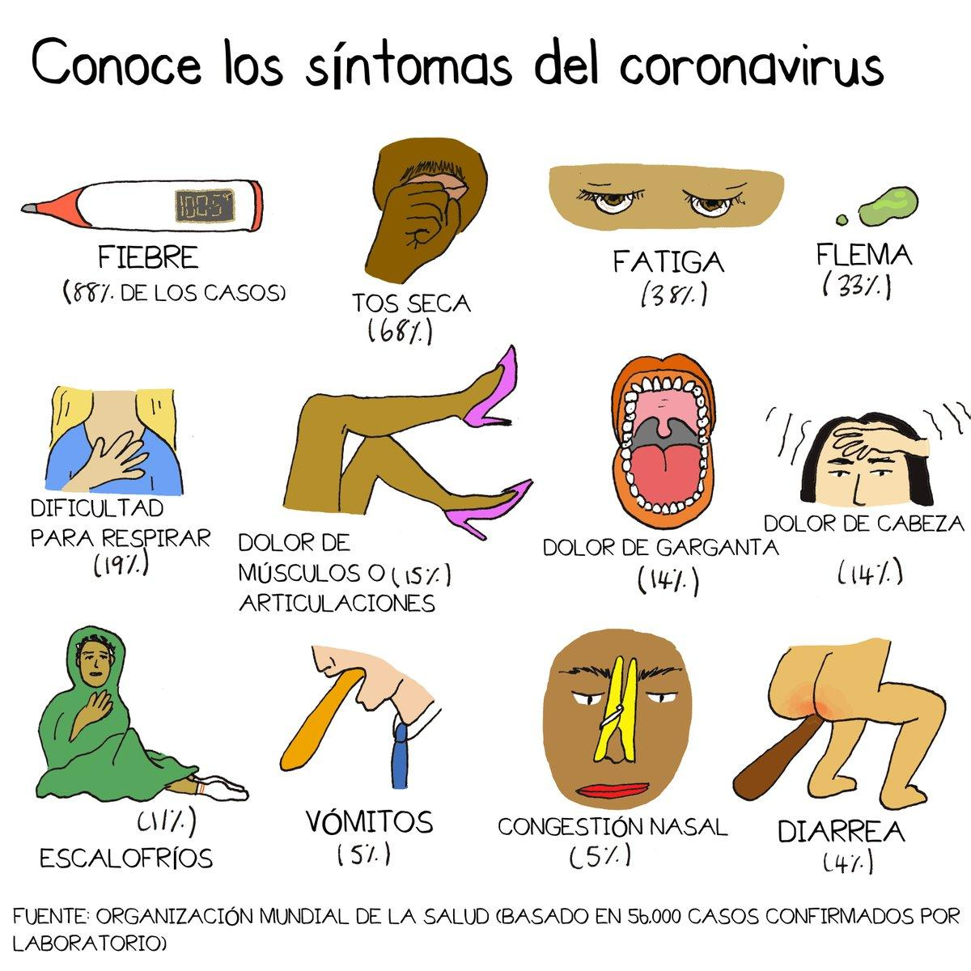

Información sobre el virus

Respuesta del Gobierno ante el coronavirus (COVID-19)
- Sitio del Departamento de Salud de Nueva York sobre coronavirus
- Sitio del Center for Disease Control (CDC) (Centro de Control de Enfermedades) en español

En Français
Cette document inclut des ressources et d’information pour vous aider pendant ce temps difficile. Tout ce qui est en anglais n’est pas reproduit ici, mais l’information général est répété. Il consiste des ressources pour les jeunes et leurs parents par rapport à l’apprentissage à distance; des ressources alimentaires et financières, concernant du logement et charges, et soutien général; ressources de santé physique et émotionnelle; et information et ressources sur le virus. Il y a des liens aux sites spécifiques et aux ressources en anglais mentionnés en haut.
Si vous avez des questions concernant ce document ou si vous avez mal à comprendre des partis en anglais, vous pouvez contacter Tess.Weiner@archny.org

Ressources pédagogiques pour les jeunes et leurs parents
- Information concernant l’apprentissage à distance
  - Lien pour demander des dispositifs d'apprentissage à distance
  - Créer le compte d'étudiant.e, pour accéder à Google Classroom et télécharger Microsoft Office (en anglais)
  - Guide pour connecter à Google Classroom (anglais)
  - Guide pour connecter à Google Classroom et Microsoft Teams (anglais)
    - Besoin d’aide? Envoyez un texto à 718-673-2430 ou appelez DOE Service Desk (718)-935-5100
  - Si vous n’avez pas du wifi chez vous:
    - Comcast - Essentials internet service sera gratuit pour 60 jours. Voir le site https://www.internetessentials.com/ pour plus d'info (anglais). Appelez 1-855-8-INTERNET pour le faire installer
    - Spectrum offre du broadband et Wi-Fi gratuit pour 60 days pour des familles avec étudiants, et frais d’installation gratuit pour nouveaux client.e.s. Appelez 1-844-488-8395
- Repas à emporter (gratuit) - récupérer à l’école 7:30-13:30
  - Vous pouvez aller à n’importe quelle école (pas forcément laquelle où vos enfants assistent) - trouver l'école la plus proche ici
  - Pas besoin d'identification, documents, etc. - personne va être refuser
  - Vous pouvez récupérer les 3 repas au même temps, mais seulement à emporter
- Centre d’enrichissement régional (Regional Enrichment Center - REC): centres pour garder les enfants des travailleurs en médecin, pour MTA, police, etc. Accès aux cours et autres activités, en plus de 3 repas par jour. Ouvert 7:30-18:00 en semaine, maximum 12 enfants par salle avec un.e adulte.
  - Inscrivez-vous ici (en anglais)
- Activités pédagogiques
  - Pour la petite enfance: Information et Ressources
  - Pour des élèves plus âgés et en matières diverses, en anglais
  - Plusieurs ressources de lecture en anglais: voir “Reading Resources” en haut
  - Pour les parents: Literacy Partners est une association qui donne des cours d’anglais, d’alphabétisation
  - Accès à distance à la bibliothèque publique (site en anglais)
    - Soutien scolaire/cours particuliers gratuit tous les jours entre 14 h et 23h, en anglais et espagnol, pour les élèves du primaire et du secondaire
    - NYPL propose également des liens vers de nombreuses ressources incroyables pour soutenir les enfants pendant leur apprentissage, certaines accessibles uniquement via un compte NYPL. Cliquez sur le lien pour plus de détails, ventilés par tranche d'âge.

Aliments et livraison, logement et charges, autres aide
- Invisible Hands: livraison gratuite pour les communautés à risque, par des bénévoles de votre quartier (site en anglais, mais ils ont du personnel / des bénévoles bilingues pour aider avec d'autres langues)
- C19 Help Squad: formulaire à remplir pour obtenir fournitures et/ou aide financière, etc. (site en anglais, mais ils ont du personnel / des bénévoles bilingues pour aider avec d'autres langues!)
- Queer support group - possibilité de demander des services

Santé physique et émotionnelle
  - CDC Que faire si vous êtes atteint de la maladie de coronavirus (COVID-19)
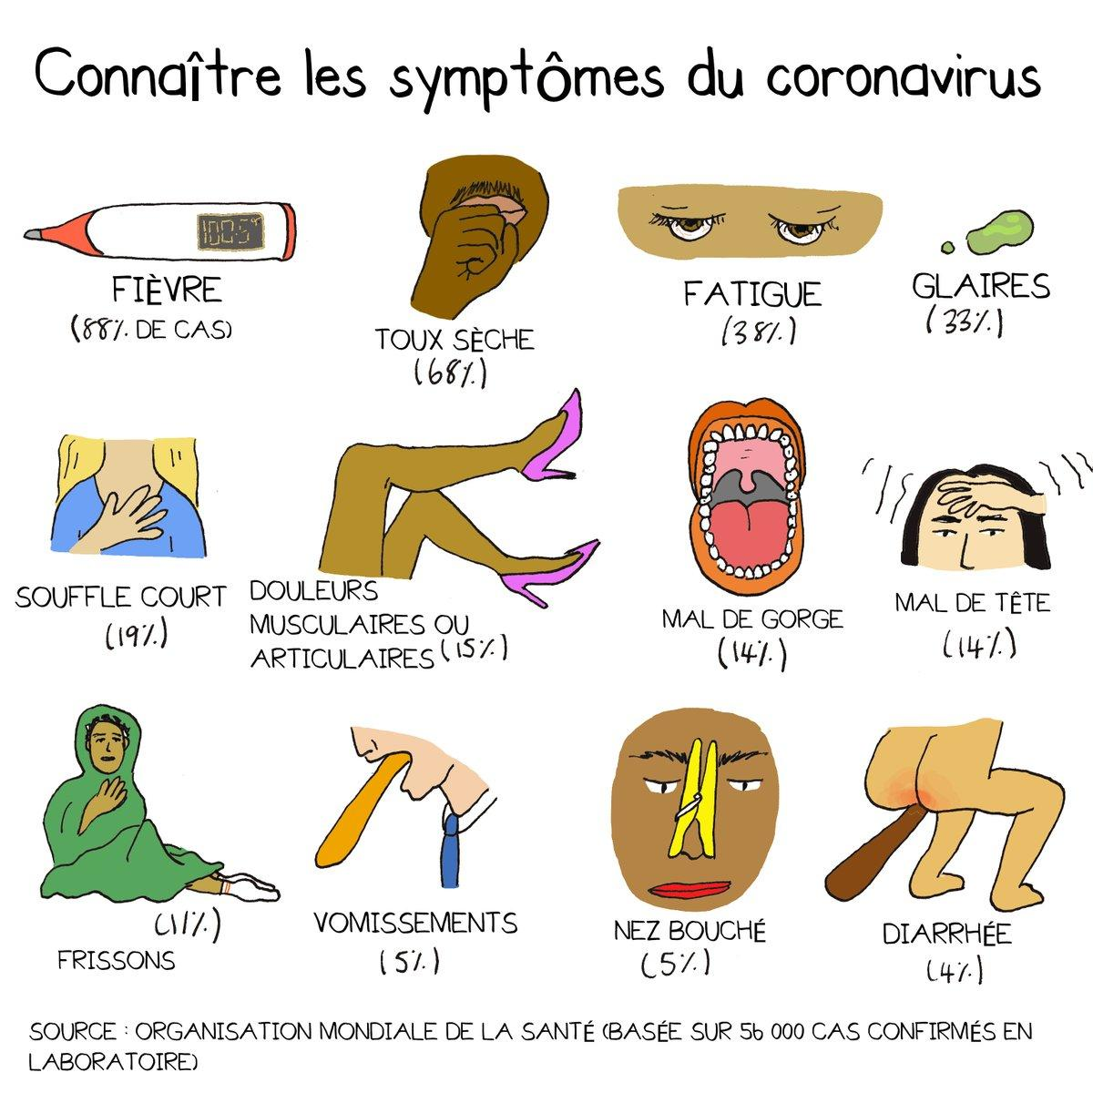

Information concernant le virus
- Site du ministère de la Santé de New York sur le coronavirus - traduisible en français
  - Text COVID to 692-692 for NOTIFY NYC Emergency Updates (en anglais)
- New York State Coronavirus Hotline - 1 (888) 364-3065
- Réponse du gouvernement fédéral au coronavirus (en anglais)
- Site de Center for Disease Control (centre de contrôle des maladies) dédié à Coronavirus (en anglais)
- Des autres ressources en anglais se trouvent ici

